Positive Pay – Commercial Center Guide

Check Positive Pay Page

The Check Positive Pay page allows you to complete several functions within one place, such as:

- Review Exception Items
- Import an issued check/void check file
- Manually add an item
- Search for specific items and view all decisioned items

- Click on Control & Recon.
- Under Control & Recon, click Check Positive Pay. The following page opens.

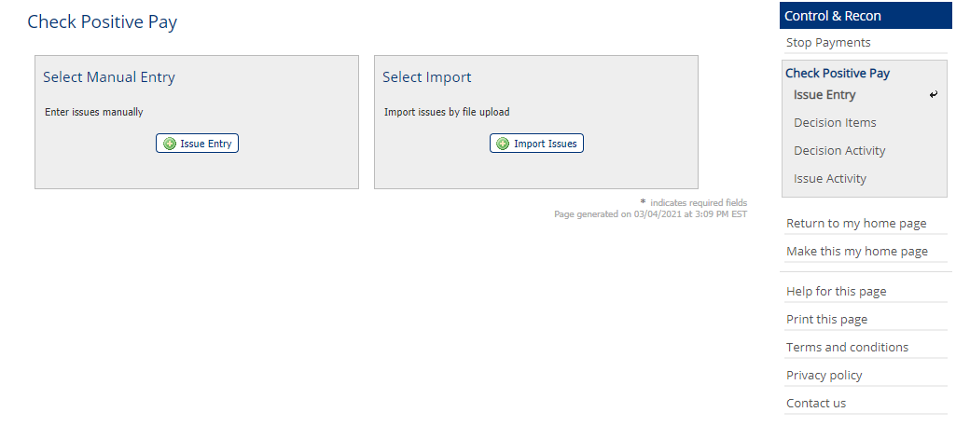
From this page you can enter checks into the Positive Pay system, Decision Exception Items, and review previous items Decision/Issue Activity.

Review Exception Items
If there are items to review and decision, they appear in the Decision Items section on the right-hand side of the page.

To decision an item:
- Click Decision Items.
- Choose your option to Pay or Return the item.
- If Return, choose the Return reason from the Drop-Down menu.
- Select Enter Decisions, then select Save if the decisions are correct. Select Reset if corrections are needed.

Items can also be decisioned on the main Welcome Page. On the right-hand side under Action Center, click Check Positive Pay Exceptions.

- The Decision Item Review must be completed by 11:00 AM each business day. If a default decision has been provided, the default will take effect at 11:00 AM if decisions have not been made.
- In the event that the Commercial Center is unavailable due to disruption in communications or associated reasons, Customer may advise Bank of item decisions by email to cashmgt@midpennbank.com. In the event that email is not available, item decisions may be conveyed to Bank by phone to 717-920-8349. The call will be transferred to a recorded line.

Import a File

To import a file:
- From the Select Import click on Import Issues.
- From the File Maps list, select the template that is formatted to read the file, either .csv or txt.
- Click Upload, click on *Select File, locate and select the file.
- Click Upload File.

If there are no exceptions the File Validation page will appear, click OK. If there are exceptions the File Validation Report will appear and outline what items need to be corrected in the File in order for it to upload correctly.

Note:
- In the event that the online business banking system is unavailable due to disruption in communications or associated reasons, Customer may advise Bank of checks issued by email to cashmgt@midpennbank.com. In the event that email is not available, check issues may be conveyed to Bank by phone to 717-920-8349. The call will be transferred to a recorded line.

To Manually Add Checks

- On the Check Positive Pay page, in the Select Manual Entry section, click Issue Entry.
- Enter your check information Account Number, Issue Date, Check Number, Amount, Payee (check the Void Check box if this check was voided. This option does not replace the method of issuing a Check Stop Pay).
- If a further description is required click the Description box to enter more information.
- If more rows to add checks are required, select how many more rows you need and click +Add.
- Once all checks have been entered click Submit.

To Inquire on Issued Item(s) Activity

- On the Check Positive Pay page, on the right-hand side click, click Decision Activity.
- Searchable fields are Dates, Users, Status, Decision, click Search.
- On the Check Positive Pay page, on the right-hand side click on Issue Activity.
- Searchable fields are Dates, Users, Status, Decision, click Search.

Positive Pay File Creation:

The source file needs to be created in Excel and must be converted into a Comma Delimited (.csv).
This format is easily accomplished by taking an Excel spreadsheet and saving it as “CSV (comma delimited)”. The file cannot contain any commas.

The format of the import template will be:
Column 1 – Account Number
Column 2 – Issue date in mm/dd/yyyy format Item Number column
Column 3 – Item Number column
Column 4 – Amount column (.00 format with decimal, no comma)
Column 5 – Item Type Code column - Item types are “1” for Issue and “2” for Void
Column 6 - Payee Column

The source data file must be converted to the above format in order to properly process.

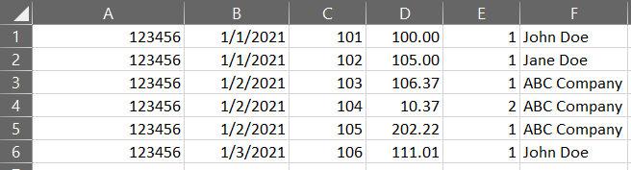

This file is arranged exactly as described in the guide with check date, check number, dollar amount, item type and payee name displayed. The “commas” are assumed to reside between each field. It is important to note that there are no commas within any of the fields. This is essential. If a comma was used in the amount field, or in the payee name field, the program would assume that another field would follow that comma, and the entire file would be thrown off.

Testing Positive Pay Issue Files

For initial customer testing and setup please submit all test files to Mid Penn Bank and Cash Management Operations will test initial files.

Any questions please contact:

Cash Management Operations:
cashmanagementopscenter@midpennbank.com
717-920-8349

Andrew George
andrew.george@midpennbank.com
717-216-5760
Monday-Friday 8:00 AM-5:00 PM EST (Closed weekends and Government Holidays)

