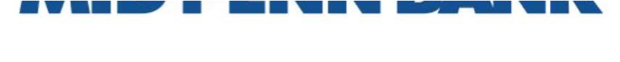
Remote Deposit

Quick Reference Guide

- Clean the scanner thoroughly before processing any deposits.

- Prepare checks for deposit:
  - Make sure all checks are facing forward with the MICR line in same direction.
  - Ensure all staples, paperclips and rubber bands are removed.
  - Add checks together to come up with the deposit total. You will be prompted to enter your check total before scanning your deposit.

- Open your browser and go to www.midpennbank.com to log into Commercial Center.

- Hover over and click on Payments & Transfers and click on Remote Deposit. Click on the green arrows Continue to Remote Deposit? This will take you to the Remote Deposit scanning site.

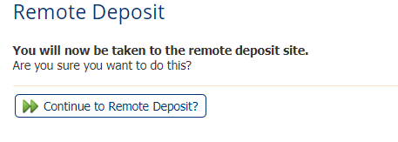

- Click on the yellow Create Deposit button on the left-hand side of the screen.
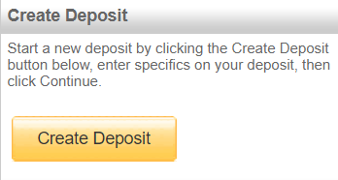

Enter your deposit name, amount, and account (drop down box if you have multiple accounts)

- Place first check of the deposit in scanner with the front of the check facing to the right or as indicated on the scanner.

- Push check forward in the scanner until it is fully in the scanner. Click on the Scan button.

  - For Panini (Single Feed) Scanners, press the scan button first and then begin inserting your first check.

- After all items have been scanned check to see if there are any errors. Go back into the items that have issues and correct required issues, hitting enter to complete the changes.

- Verify Deposit Totals and Check Totals equal. If balances equal each other, click the Submit Deposit button. When the deposit is submitted it will be changing to a Pending Review status when it is received at the Bank. If any reviews are required the status will change to Under Review. When the deposit has processed it will change to Delivered.

  - If a deposit has a status of Suspended or Ready for Approval the scanned deposit needs to be Submitted or Deleted.
    - To reopen a deposit from the home page, elect the view deposit option associated with your suspended deposit:
      - 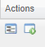
    - Once your deposit is re-opened, you will have the option to either submit, or delete the scan.
      - 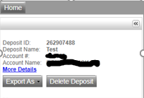
        - Note: once a deposit is submitted, you will no longer have the option to cancel that deposit.
- Once you have completed a deposit submission, you also have the option to export that deposit with, or without, your check images.
  - Select the reports tab
    - 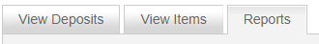
  - Select the view deposit option
  - Once in the deposit, click the export selection on the left of the screen to open the dropdown and select your export option.

** If you receive a message that your deposit it is over your daily limit you will need to email Cash Management at cashmgt@midpennbank.com to request a Daily Temporary RDC Limit Increase. In your request please list your total Deposits for the day and the amount you are requesting your Limit be temporarily increased to, please account for deposits already made, as well as any other deposits needed for the day.

Any questions please contact:

Cash Management Operations:
cashmanagementopscenter@midpennbank.com
717-920-8349

Monday-Friday 8:00 AM-5:00 PM EST (Closed weekends and Government Holidays)

Rev 03.12.2021

